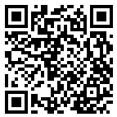
Please take out garbage by 8:30 am on the day of collection.
How to separate and dispose of household garbage
（limited to household waste only）

You can check how to separate garbage and other information by scanning this QR code with your smartphone.→

Types |  | How to separate garbage |  | How to dispose of garbage
Burnable Garbage |  | General household garbage, paper, fibrous waste, wood scraps, grass, bags, shoes, CDs, DVDs (Including cases), Styrofoam, hangers (Plastic), plastic tube type containers for mayonnaise and such, disposable heating pads, oil bottles, aluminum backed paper packs, etc. | 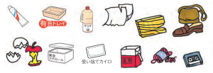  Colored tray  Disposable heat pack | ○Be sure to take garbage out in designated translucent yellow Seki City bags.  ○Drain liquids thoroughly before taking garbage out.  ○Remove air and tie the bag off securely.  ※Break Styrofoam into pieces about the size of your fist.  ※Be sure not to put incandescent light bulbs or cooking implements into burnable garbage.  ※Futons or carpets and such may be placed into burnable garbage if they can be cut up small enough to fit into burnable garbage. | 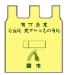  Large (10Bags)\500  Medium(10Bags)\300  Small (10Bags)\200
Non-burnable Garbage |  | Pots, kettles, and other metals, bowls, plates, vases, flower pots and general household ceramics, light bulbs, mirrors, umbrellas, boards, heat resistant glass, cups, watering cans, planter pots, toys, buckets, (metal) hangers, poly-tanks, metal lids and caps, etc. | 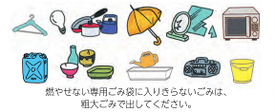  If your non-burnable waste does not fit into the designated garbage bag, please dispose of it as oversized garbage. | ○Be sure to take garbage out in designated translucent light blue Seki City bags.  ○Wrap light bulbs, knives, razors and such, securely and put it out in a manner that eliminates danger.  ※Soil, tiles, concrete pieces will not be collected.  ※Be sure to remove oil and batteries from machines.  ※Do not dispose of dangerous goods such as gas canisters or spray cans with any contents remaining. This may cause explosions or fires during garbage collection. Further more do not put lighters directly into the garbage bag, place them in a smaller bag, write (Lighter) clearly on it and tie it to the handle of a non-burnable garbage bag.  ※Do not mix with burnable rubbish. | 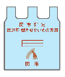  Large (5Bags)\500  Small (5Bags)\200
Recyclable wastes | Pet Bottles | 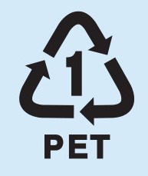Household pet bottles. (Items with a PET 1 mark)  ☆ Water bottles, mirin type seasoning or soy sauce products, etc | 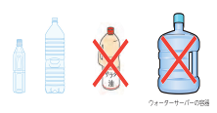  Water dispenser bottles | ○Caps（Caps are burnable garbage）should be removed and washed with water.  ○Do not crush, dispose of them as they are.  ○Be sure to remove the label.  ○Put the removed label in burnable garbage.  ○Place soiled or colored bottles in burnable garbage.  ※Place bottles for oil in burnable garbage. | 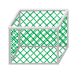
Recyclable wastes | Trays | General household white food trays | 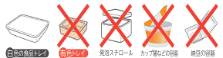  styrofoam  Colored tray  White food tray  Natto foam container  Instant noodle cup | ○Colored, patterned or soiled trays should be put in burnable garbage.  ※Styrofoam should be broken into pieces the size of a fist and put in burnable garbage. | 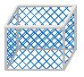
Recyclable wastes | Cans | General household juice, beer, snack, food grade oil and other steel cans, aluminum cans, gas cassettes, spray cans. | 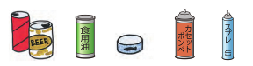 | ○Do not pierce spray cans and gas canisters before putting them out.  Be sure to ensure all contents have been removed and that no gas remains before disposal.  ○Do not crush cans, place them in the basket as is.  ○Empty contents and rinse soiled items with water.  ○Lids and caps are non-burnable garbage, however if they cannot be removed dispose of them still attached. | 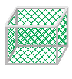
Recyclable wastes | Glass Bottles | General household alcohol, beer, nutritional drink, soy sauce, sauce, make up and other glass bottles.  Non-colored: Clear bottles.  Brown bottles: Nutritional drink bottles, etc. Beer bottles: Regular and large bottles. | 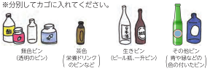  Other colored bottles  Brown bottle  Please separate the bottles and place them in the designated bin.  Reusable bottle  Colorless bottle | ○Place items directly into the basket.  ○Remove lids and related parts, wash with water and separate by color into the designated basket according to the image on the left.  ○Labels do not need to be removed.  ○Dispose of broken bottles in non-burnable garbage.  ※Be sure not to dispose of glass cups, bowls, pottery, ceramics or florescent light bulbs. | 
Paper garbage and used clothing should be disposed of at locals collection areas, elementary, junior high school or PTA collection events.
Recyclables collected at drop-off centers  ※Items from businesses, such as offices and shops, cannot be collected. | Floresent lights  and batteries | General household florescent (Straight, rings and bulbs).  Items containing mercury (Mercury thermometers, blood pressure meters containing mercury)  Dry cell batteries. | 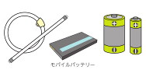  Power bank |  |  | ※ LED Lamps, incandescent bulbs, halogen bulbs, glow bulbs are not included. Dispose of them in non-burnable garbage.  ※Lithium batteries, power banks, button batteries, nickle-metal hydride batteries, NiCd batteries, rechargeable batteries will be collected.  ※Electronic items with lithium batteries inside (Shavers, cordless vacuums, etc) will be collected. |  |  | Collection Center  January 2025 Current
Florescent light bulbs, Items containing mercury, varieties of batteries, used small electronic goods.
Ink cartridge collection area
 | Used Small Electronics Device | In order to recycle your small household electronics, please use the collection box located at city facilities. | 65 types of used Small Electronics for collection | Items listed to the right that will fit into the collection box will be accepted.  (Less than 15cm tall, 40cm wide and 30cm in depth. | Mobile phones, PHS | Various phone manufacturers, PHS Devices
 |  |  |  |  | Personal Computers | Desktop computers, laptop computers, LCD monitors, Tablets
 |  |  |  |  | Cameras, Video cameras | Cameras, Digital cameras, Digital video cameras. |  |  | Environment Division (Seki City Hall)  Western Branch Office  Horado Office  Itadori Office  Mugegawa Office  Mugi Office  Kaminoho Office
 |  |  |  |  | Phones, Fax machines | Phones, Fax machines
 | Used Small Electronics Device | 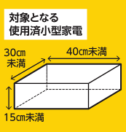  ➊ Less than 30cm in depth  ➋ Less than 40cm wide  ➌ Less than 15cm tall  ➋  ➌  ➊  Used Small Electronics for collection/recycling | 65 types of used Small Electronics for collection |  | Video players, Recorders | DVD players, HDD recorders, BD recorders/players, Video decks
 |  |  |  |  | Audio equipment | CD players, MD players, radios, Miniature music players (Memory type, HDD type), IC recorders, Tape recorders, Headphones/Earphones, Hearing aids.
 |  |  |  |  | Storage media | Hard discs, USB memories, Memory cards
 |  |  |  |  | E-book readers | E-book readers, Electronic dictionaries, Calculators
 |  |  |  |  | Health goods | Electronic blood pressure monitors, Electronic thermometers
 |  |  |  |  | Used goods | Dryers, Hair irons, Electronic hair clippers, Electric shavers, Electric shaver cleaners, Electric tooth brushes
 |  |  |  |  |  |  |  |  | Ink cartridge only collection area
 |  |  |  |  | Video games | Home video game consoles, Video game controllers, Miniature video game controllers, Mini electronic video games, Electronic toys |  |  | Ink cartridge only collection area
 |  |  |  |  | Car goods | Car navigation units, Car televisions, Car tuners, Car stereos, Car radios, Car CD players, Car DVD players, Car MD players, Car speakers, Car amps, VICS devices, ETC units |  |  | Wakakusa Plaza Learning Information Center  Horado Fureai Center  Itadori Fureai Center  Mugegawa Lifelong Learning Center  Mugi Lifelong Learning Center  Kaminoho Lifelong Learning Center
 |  |  |  |  | Other eligible goods | Torches, Watches, Remote controls, Keyboards, Mouses, AC adaptors, Cables, Chargers, Plugs
 | Ink Cartridges | Domestic printer ink cartridges | 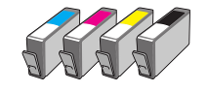 |  |  | ※Jet Corporation has a collection scheme.  ※Place returns in the cardboard box at collection areas. | 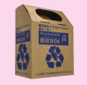

Types | How dispose of garbage |  | Examples of garbage
Oversized Garbage | City collection（Items that won’t fit into designated bags）  ○Length・Weight・・・Items longer than 2m・Less than 60kg  ○Handling fee・・・1 item 500円（Please purchase an Oversize garbage sticker）  ○Number of items・・・Five items at one time  ○Application method・・・Apply up to five business days before the collection date using the QR code to the right, or before collection day when City Hall is open, apply before 3 pm at the Environment Division, Western Branch Office, or local offices.  ○Disposal method・・・Attach the 「Oversize Garbage Sticker」, place the items by the roadside (Where it can be stacked easily) in the non-burnable garbage station.  ※Depending on the type, garbage may not be able to be collected. | 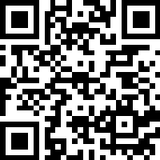  Bulky waste sticker  粗大ごみ用シール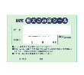 | 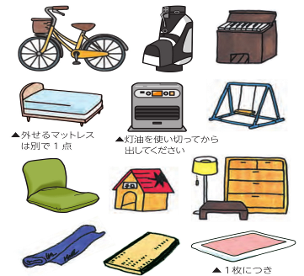  Please dispose of the stove as waste after completely  using up all the kerosene.  For futons, each futon counts as one item.  Detachable mattresses are counted separately from the bed frames.  Example: futons, furniture, bicycles, and  home appliances.(Certain home appliances  such as televisions, washing machines, refrigerators,  freezers, air conditioners, and clothes dryers cannot  be discarded as bulky waste.)
Oversized Garbage | Self delivery ※Application in advance is required.  ○Delivery location・・・Clean Plaza Chuno☎（0575）23– 1173  ○Reception・・・Weekdays、February～December, First Sunday of the month 8:30 to 4:30  （Excluding New Year’s break）  ○Fees・・・Every 10kg costs 200円（Will be weighed, please pay in cash）  ○Application method・・・Apply using the QR code on the right. Apply on paper at the Environment Division, Western Branch Office, or local offices.  ※Please apply in person should special circumstances regarding delivery or other, of household garbage be present.  ※Please follow the guidance of the Clean Plaza Chuno Staff when on the premises. | 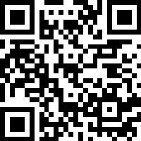
General refuse, rubble | Self delivery ※Application for self delivered waste・Application form （Rubble) required.  ○Rubble・・・concrete、roof tiles、brick、tiles（Restricted to general household refuse）  ○Delivery location・・・Clean Plaza Chuno ☎（0575）23 – 1173  ○Reception・・・Every Tuesday 1 pm～ 4:30 pm（Excluding New Year’s break and public holidays）  ○Fees・・・Every 10kg costs 200円（Will be weighed, please pay in cash）  ○Application method・・・Environment Division or local offices.  ※No applications take the Western Branch Office.  ※Please follow the guidance of the Clean Plaza Chuno Staff when on the premises. | 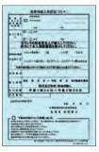 | 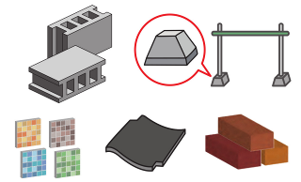
to recycling ordinences  Electronic goods subject | ○Air conditioning units, TV’s, refrigerators, freezers, washing machines, clothes dryers cannot be disposed of in oversize garbage according to recycling ordinances. Retailer collection is available for household electrical goods that may produce emissions.  ※Items differing the above.  Apply for a recycling certificate at your post office, then you can take it to a designated collection area.Or collection services listed on the left may be employed. (Collection services require additional fees.)
  Authorized Collectors/Recyclers for Home Appliances Subject to the Recycling Law
  Chuno Clean Consultant | ☎ 0575−27-2077 | Seki, Horado, Mugegawa areas |  | ※Electrical recycling certificate applications can be requested at Chuno Clean Consultant and Hashimoto.
  Hashimoto | ☎ 0574−63-1111 | Seki, Mugegawa areas
  Seki Kankyo Service | ☎ 0575−22-3183 | Seki area
  Chuo Seiso | ☎ 0575−22-0549 | Seki area
  Mino Setsubi | ☎ 0575−33-0537 | Itadori, Mugi, Kaminoho areas
Items cannot that | 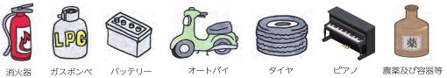  Agricultural chemicals  Piano  Tire  Motorcycle  Car battery  Fire extinguisher  Gas cylinder |  | ○Cannot be collected by the city.Please consult at the point of purchase.  Items indicated on the left or commercial waste (Construction waste, commercial plastics, office machines, dismantled car parts, etc）

Regarding cutlery recycling
Unwanted or broken items can be collected
by the Gifu, Seki City Cutlery Manufacturer Federation.
Collections of items are on November 8th (Cutlery Day)
at the recycling event and are reused or recycled.
Collection boxes are located in City Hall, other local
offices, the Hamono Kaikan or other cutlery retailers,
please wrap unwanted items in paper and take them in.
PC Collection
➊Home collection
○Computers, （main body included） are free of charge for up to one box.
○Printers and related items can be collected together.
○There is a service for deleting personal information available.
Renet Japan Recycling
〈URL〉https://www.renet.jp/
〈TEL〉0570-085-800（10 am〜 5 pm）

❷Maker Collection
Home built or unknown branded computers, please inquire below.
General Incorporated Association 3R Promotion Association
〈URL〉https://www.pc3r.jp/
〈TEL〉03-5282-7685
※Mon〜Fri（Except New Years and public holidays）Open：9 〜 12 am、1 pm〜 5 pm
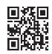
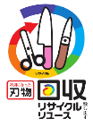

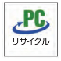

○Place burnable, non-burnable and recycling in your specified local garbage station on the morning of the collection day by 8:30 am.
○In the case of large amounts of garbage, please do not take it to the local area but to Clean Plaza Chuno directly, or organize collection with an authorized organization.
○Garbage taken out after collection time will not be collected.
○Garbage not placed in specified Seki City garbage bags will not be collected.
○Garbage that cannot be separated will not be collected.

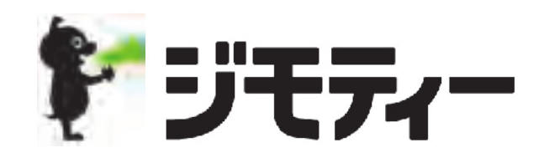
Jmty has local information sites where items can be listed for connecting interested individuals for pickup.
○ The local information sites (Jmty) can be accessed by either the web site or app.
○ Access by computer or phone is possible.
○ The app is available in both iOS and Android.
〈URL 〉https://jmty.jp

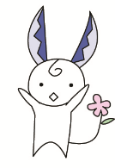

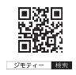
The garbage station belongs to the neighborhood. Please contact the neighborhood association before using it. Furthermore be sure to follow the rules regarding times, etc and maintain hygiene and cleanliness.

Contact Information | ■Regarding garbage collection calendars, garbage separation and disposal  ●Environment division（Seki City Hall）…☎(0575)22-3131(Rep) ●Horado Office…☎(0581)58-2111 ●Itadori Office…☎(0581)57-2111  ●Mugegawa Office…☎(0575)46-2311 ●Mugi Office…☎(0575)49-2121 ●Kaminoho Office…☎(0575)47-2001
Contact Information | ■Regarding garbage collection, garbage stations ●Seiso Office…☎(0575)22-0314
Contact Information | ■Regarding Clean Plaza Chuno ●Clean Plaza Chuno…☎(0575)23-1173
Contact Information | ■Garbage colection calenders can be downloaded from the Seki City homepage. URL：https://www.city.seki.lg.jp/

